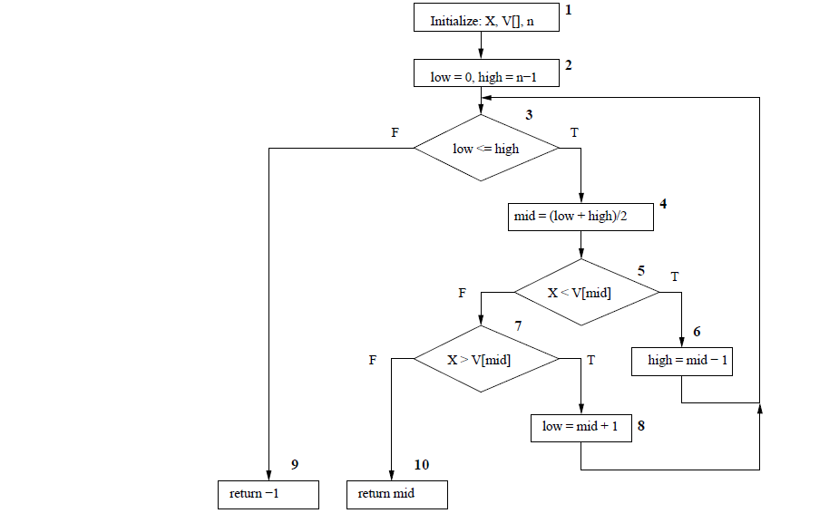

**Statement Coverage:**

• Path 1: 1 – 2 – 3 – 4 – 5 – 7 – 10.

• Path 2: 1 – 2 – 3 – 4 – 5 – 7 – 8 – 3 – 9.

• Path 3: 1 – 2 – 3 – 4 – 5 – 6 – 3 – 9.

Branch Coverage:

Same